
Procedure 2025

ArcelorMittal Building Solutions France Procedure 1.1.1.3

Credit note & invoice validation

Table of contents
- Credit claims 3
- Validation of credit notes & invoices 3
  - No change in payment terms 3
  - With change of payment terms 4
  - Internal assets 5
  - Discount credit notes 5
  - Commissions 7
- Filing edited documents 6

Credit claims

When there's a dispute over one or more invoices (transport, price, materials, etc.), sales staff open claims with the after-sales service. Once an agreement has been reached, credit applications are drawn up and sent to various validators before arriving at the credit manager.
The Credit Manager regularly extracts MoovApps' credit notes in an Excel spreadsheet. Once he has validated this table, the credit notes can be validated.
It is possible that the format will change and that the DAs will be presented in paper format.
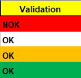
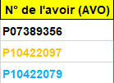

White = To be validated

Black : Mail
Orange: EDI
Blue: Demat Invoice
Red = Do not validate

Orange = Modification
Green = Already validated

NB: If the AVO number cannot be found, please ask your manager to verify it.

Validation of credit notes & invoices

No change in payment terms
- Premium Account / Invoice request validation :

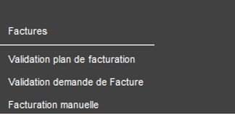
- Enter order number (AR):
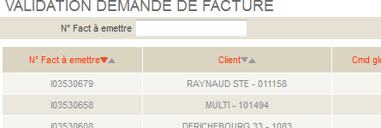
Order number (AR)
ex: I03529586

- Check data to ensure compliance with credit note requests: Customer Customer name - Sofie code - credit note/invoice - amount excl. and incl. VAT

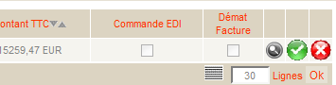
- Then confirm :

The credit note can be printed in one or more copies

  - With change of payment terms (most common)

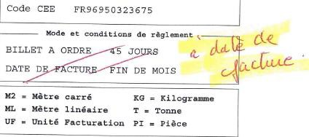
    - Enter the Order number (AR) , then click on the magnifying glass :
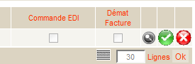
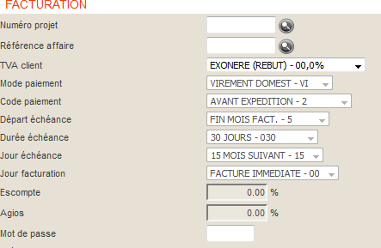
happy (data entry unlock)

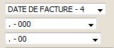
- Validate the order / Complete my order / then validate the credit note:

 When a modification is made, a credit memo is issued (for disposal).
Be sure to wait until this has been edited before validating the credit (otherwise the changes made will be lost).
will not be taken into account)

  - Internal assets (Exceptions)
(Usually specified on the application or by e-mail or on MOOVAPS)

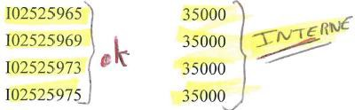

    - Enter the AR number, and uncheck the EDI and Démat facture boxes.
If the check mark is greyed out, use the magnifying glass (as seen in the previous point) to uncheck EDI & Démat / validate the order / Complete my order (a credit note request will appear again) then validate the credit note.
AVOIR INTERNE or Valérie V
= EDI +DEMAT TO UNCHECK

Discount credit notes

è See procedure 1.1.1.2

Filing edited documents
- Classic credit applications :

Vdoc credit requests Simple credit note requests

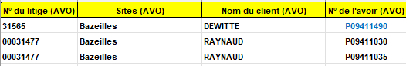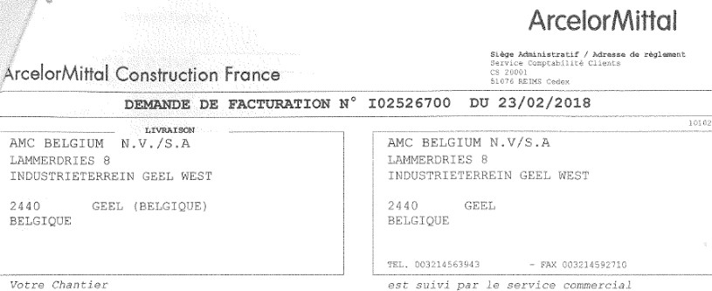

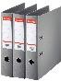


1 original to customer

1 original to customer

Vdoc to be stored in the binder

The rest to throw away

To have
+ 1 stapled copy for filing

The rest to throw away

For internal credit balances:

Cdt note request
+ 1 stapled copy for filing

Vdoc to be stored in the binder

The rest to throw away

OR

- Sales = Valérie VARIN
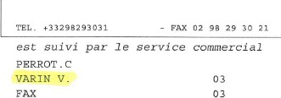



Cdt note request
+ 1 stapled copy for filing

Original + 1 copy for Valérie V.

The rest to throw away

- Internal + Valérie VARIN:
1 copy for Valérie V.

The rest to throw away

Cdt note request
+ 1 stapled copy for filing

Discount credit balances

è See procedure 1.1.1.2

Commission/ Financial ( Exceptional at the request of the CM)

- Enter order type + Customer (Sofie code)
Always financial credit note
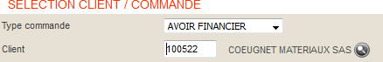

ACCEPT

- Complete the activity if it is missing, uncheck EDI and demat' and create a comment.

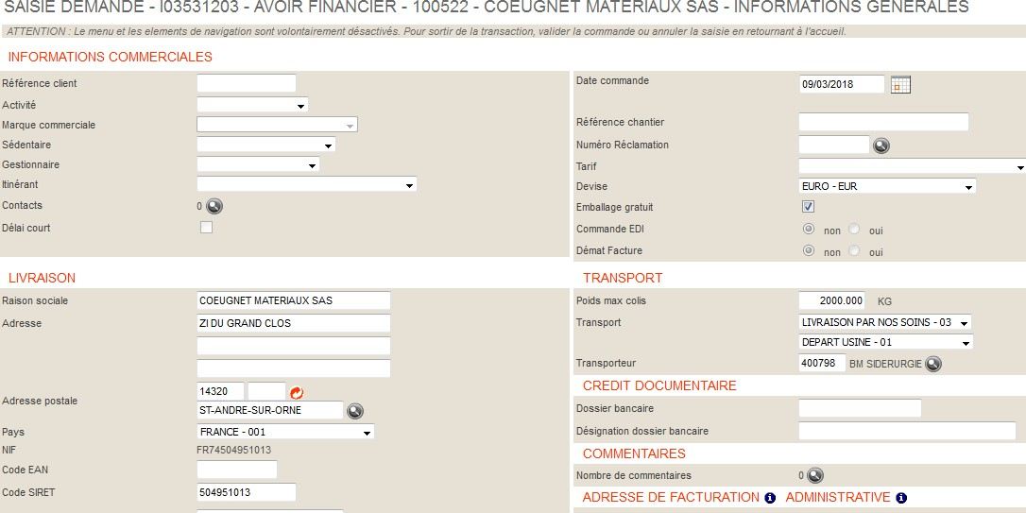
Always
NO


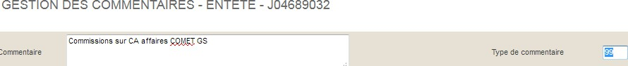

Comment: Commissions on COMET GS business / Comment type: 99 / Validate

Close the window and click on " Access the entries ".

- Complete as follows: Always enter: 2 - 09A - COMPTA10
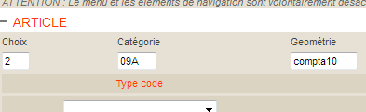


- Complete: quantity 1 / PI unit (pieces) / amount excl. tax
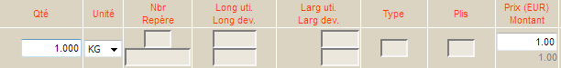
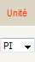

Validate entries

- Summary (CAUTION: CHECK CURRENCY USED) :
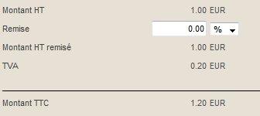

The feeling of having it

 See point 3. Filing, simple credit application.

On: 16/10/2025
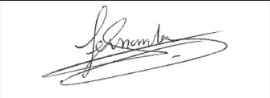
Procedure validated by : S. HERNANDEZ

